Online Shopping System: FootFusion

Use-Case-Realization Specification: Buyer Manage Order

Version <1.0>

Revision History
Date | Version | Description | Author
<21/12/2024> | <1.0> | Final Draft | Trần Đức Anh

Table of Contents
1. Introduction 4
1.1 Purpose 4
1.2 Scope 4
1.3 Definitions, Acronyms, and Abbreviations 4
1.4 References 4
1.5 Overview 4
2. Flow of Events—Design 4
2.1 Class Diagram 4
2.2 Sequence Diagram 4
3. Derived Requirements 6

Use-Case-Realization Specification: Buyer Manage Order

Introduction

Purpose
As the use case specification of “Buyer Manage Order”, with use case realization, this use case function will be showed easily and clearly with the design model.

Scope
This report bases on the system of FootFusion which one is online shopping system.

Definitions, Acronyms, and Abbreviations
User – A person who use the system of FootFusion with the demand to buy stuff (buyers and sellers).
Seller – A person who has FootFusion’s account to sell stuff.
Buyer – A person who has FootFusion’s account to buy stuff.
Admin – A person or maybe a group that Tiki has hired to operate the system.

References
Use Case Specification: Buyer Manage Order

Overview
In this use case function, we would mention to you three main points of Use-Case Realization –Buyer Manage Order of FootFusion system. At first section, the elements to create the Use-Case Realization will be described. After that is the main point of this paper – the sequence diagram, is designed to understand clearly about the system and how it works. The last one is the explanation about the meanings and values that the elements mention in sequence diagram bringing to the system of FootFusion.

Flow of Events—Design

Class Diagram
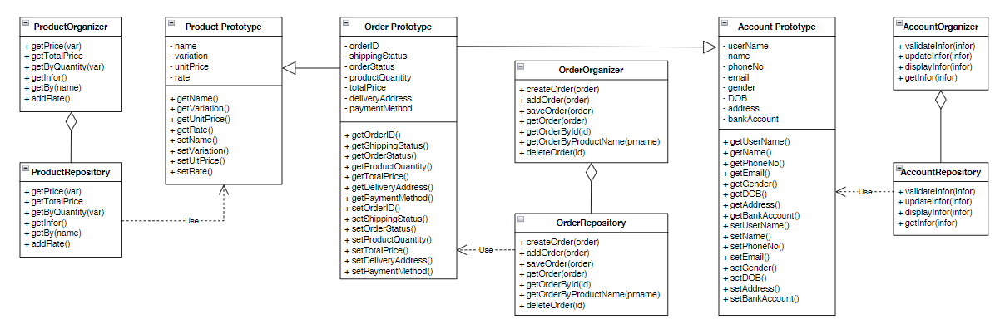

Sequence Diagram
2.1.1 Search and View Buyer Order:

2.1.2. Create Order:
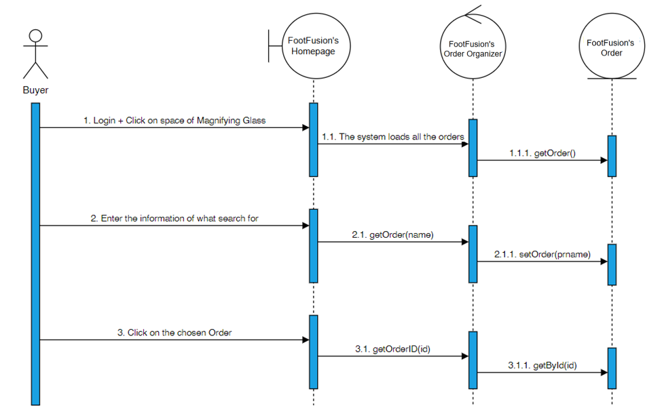

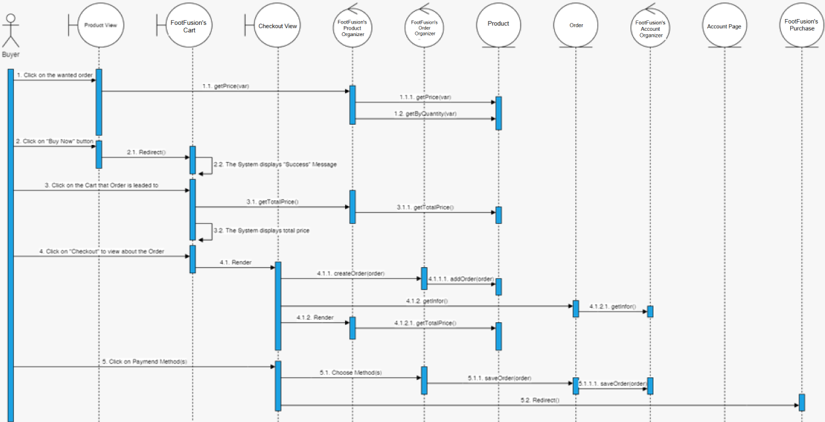

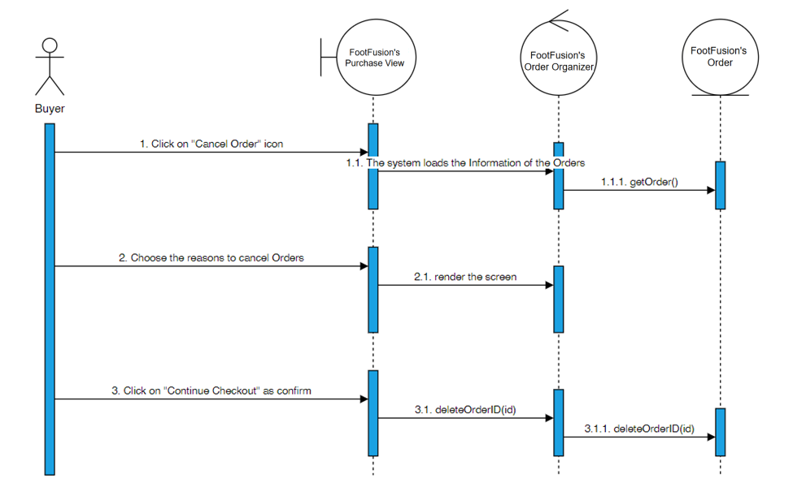

Derived Requirements
None.

